Where can I have a Pap test? 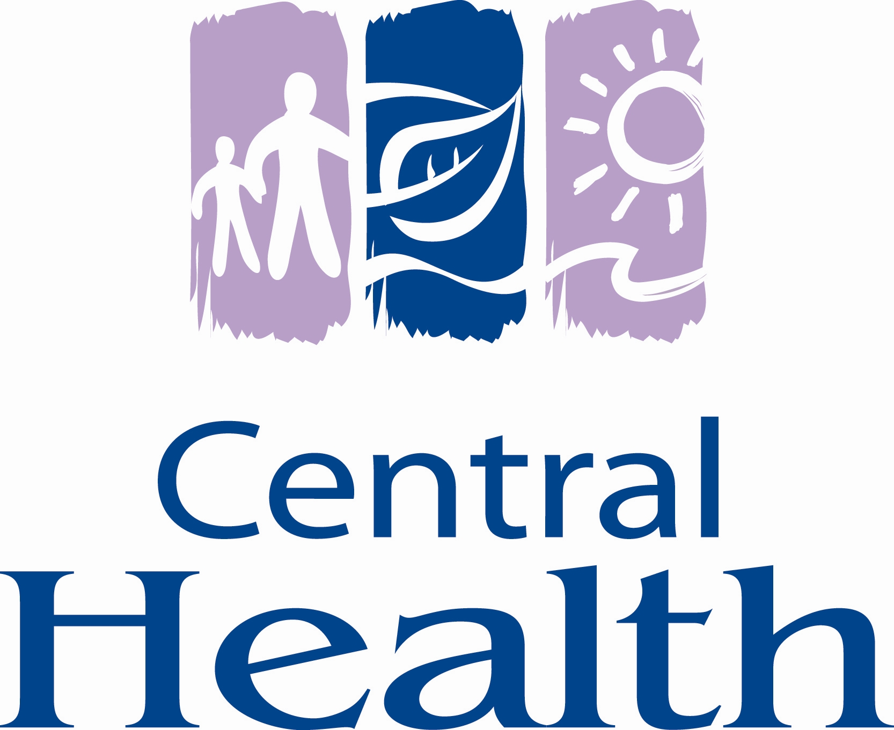
Open Door Pap Clinics -Central Health

You can book a Pap test by calling your doctor’s office, local clinic or one of the following:

Baie Verte Baie Verte Penninsula Health Care Centre 532-4281
Cathy Aylward, NP

Bishop’s Falls Bishop’s Falls Medical Clinic (Thursday mornings) 258-5555

Brookfield Brookfield/Bonnews Health Centre 536-2405
Susan Burry, NP

Buchans A. M. Guy Memorial Health Centre 672-3304
Tammy Card, NP

Change Islands Change Islands Community Health Centre 621-6161

Eastport Eastport Community Health Centre 677-2530

Fogo Island Fogo Island Health Centre 266-2221

Gander Bay Victoria Cove Community Health Centre 676- 2737
Dena King, NP

Gambo Dr. Brian Adams Community Health Centre 674-4403
Paula McDonald, NE

Gander James Paton Memorial Hospital ` 651-6261
Nancy Healey-Dove, NP

Glovertown Dr. C.V. Smith Memorial Health Centre 533-2372

GFW Killick Health Services/Martin Greenland Bldg 292-3000

Harbour Breton Connaigre Peninsula Health Centre 885-2359
Loretta Abbott, NP

Lewisporte Lewisporte Medical Clinic 535-8617

Mose Ambrose Mose Ambrose Community Health Centre 888-3541

Springdale Green Bay Community Health Centre 673-3867

St. Alban’s Bay d’Espoir Community Health Centre 538-3244

St. Brendan’s St. Brendan’s Community Health Centre 669-5381
Lenora White, NE/PHN

Twillingate Notre Dame Bay Memorial Health Centre 884-4214

